Having Fun with Integer Operations
SUNY FREDONIA
Jesse Spehar: jspehar@fredonia.edu
Trevor Delahoy: tdelahoy@fredonia.edu
The purpose of this lesson is to reinforce the rules of integer operations. We will be performing an activity that demonstrates the rules of integer operations so students can relate to the rules better. This lesson is also supposed to help students have fun while learning math.
NYS-MST standards
- 6.RP.2 Understand that mathematical statements can be supported, using models, facts, and relationships to explain their thinking
- 7.PS.1 Use a variety of strategies to understand new mathematical content and to develop more efficient methods
- 8.CM.4 Share organized mathematical ideas through the manipulation of objects, numerical tables, drawings, pictures, charts, graphs, tables, diagrams, models and symbols in written and verbal form
NCTM Standards
- Develop meaning for integers and represent and compare quantities with them.

- Explore numbers less than 0 by extending the number line and through their familiar applications

- Connect number words and numerals to the quantities they represent, using various physical models and representations
Instructional Objectives:
Following the completion of this lesson, students should be able to:
- Better understand integer operations
- Complete integer operation problems
- Have fun with integer operations
Instruction Itinerary
Start out by going over how to use the vertical number line so that students will understand how to use the manipulative, then show them how to do the activity by showing an example problem. After giving a good explanation of what the activity is about you will have many problems to give them and have many students come up and try to solve the problems using the vertical number line.

Hot Air Balloon Ride

Materials needed to build vertical number line:
- Plywood
- 2x4’s
- screws
- 2 pulley’s
- Rope
- Balloon Representations
- Basket
- Weights
- Eye Screws
- 2 bolts and nuts
Directions for putting together:
- Start with plywood approximately 7 foot long and about 18 inches wide.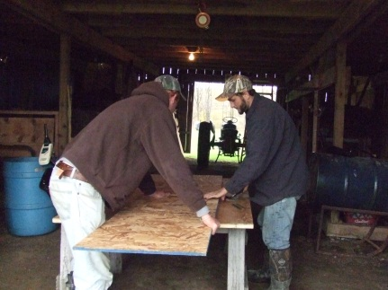
- Next we will take our 2x4’s and build a base to set our plywood on. Two sides of the base will be 36 inches long and the other two sides will be 21 inches long. You will screw them together to make a rectangle.
- You will then make two 2x4’s long enough to brace the number line so that it will stand straight up and down. These will be fastened at an angle from the back of the base to the back of the number line.
- Next you will make a channel by placing two strips of wood the length of the number line about 3 inches apart, with one in the center and the other to the left about 3 inches.
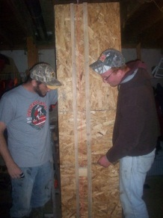
- Next we are going to set the two pulleys. First you want to make a hole at the top and bottom of the number line in between the channel. Then bolt the pulleys in place.
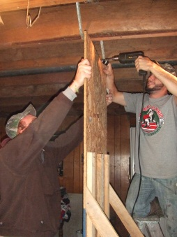
- Once the channel is set you will cut a 3x3 inch block. On two sides of the block you will screw in eye hooks. You will then tie a string long enough to one of the eye hooks so the string wraps around the front and back of the number line to the other eye hook. The line should go through both pulleys.
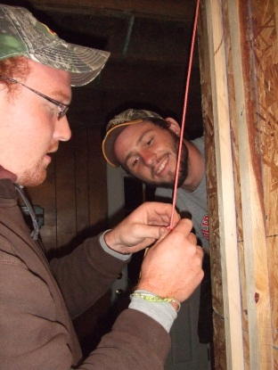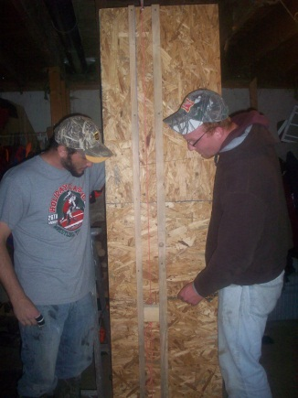

- After the basic construction is finished you can paint it and put the number line on.
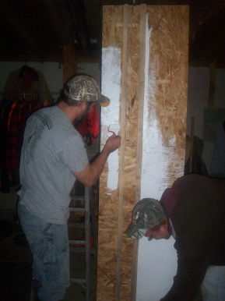
- Then once you have it painted, you will attach a basket to the block and the balloon representation to the basket. Then it will be ready for manipulation.
Directions for using the Manipulative:
Key:
Positive Integers: 1 balloon = +1
Negative Integers: 1 Weight = -1
Addition: “Put on”
Subtraction: “Take off”
- So say we have a given addition or subtraction problem. The first number, whether it is positive or negative, we are going to add on to the manipulative. If we add balloons it will be added to the balloon part and if we add weights it will be added to the basket
- Next, look at the operation. If it is addition we will add the second integer to the manipulative. If it is subtraction we will take away from the manipulative.
- So, if the second integer is positive we will add to or take away balloons and on the other hand if the second integer is negative we will add to or take away weights, depending if it is addition or subtraction.
- For this lesson it is important to understand zero pairs. You will have to take away from the manipulative so zero pairs will help us do this.
- We assume that the balloon has on/in it any number of zero pairs (i.e. as many as you need to work with)
Practice Problems and Solutions:

- $5+5=10$
Solution:
First add 5 balloons causing the manipulative to rise 5 units. Then since it is addition we are going to add on again, and the second integer is a positive so we will add five more balloons. This will result in the balloon rising to 10 units.
- $3-3=0$
Solution: First add 3 balloons causing the balloon to rise 3 units. Then since the main operation is subtraction we are going to take away, and since the second integer is positive we will take off 3 balloons causing it to fall. This will result in the manipulative stopping at 0.

- $7+\left(-3\right)=4$
Solution:
First add 7 balloons causing the manipulative to rise 7 units. Then since the main operation is addition we are going to add on again, and the second integer is a negative so we will add 3 weights causing it to fall 3 units. This will result in the manipulative stopping at 4.

- $3-5=-2$
Solution: This might look difficult but this is where zero pairs are important. Before this problem you are going to want to explain zero pairs. To do so, start by adding one balloon causing it to rise one unit. Then add one weight causing it to fall one unit. This is a zero pair. Keep adding on balloons and weight so you have a few zero pairs. Then get back to the problem. First add 3 balloons causing the manipulative to rise 3 units. Then since the main operation is subtraction we are going to take away, and since the second integer is positive we will take off 5 balloons causing it to fall 5 units. This will result in the manipulative stopping at -2.

- $5-\left(-6\right)=11$
Solution: Making sure you have some zero pairs on the manipulative, add 5 balloons causing the manipulative to rise 5 units. Then since the main operation is subtraction we are going to take away, and since the second integer is negative we will take off 6 weights causing it to raise 6 units. This will result in the manipulative stopping at 11.

- $-10-\left(-2\right)=-8$
Solution: First add 10 weights causing the manipulative to fall 10 units below 0. Then since the main operation is subtraction we are going to take away, and the second integer is negative so we will take away 2 weights making it raise 2 units. This will result in the manipulative stopping at -8.
- $-8+\left(-3\right)=-11$
Solution: First add 8 weights causing the manipulative to fall 8 units below 0. Then since the main operation is addition we are going to add on again, and the second integer is a negative so we will add 3 weights causing it to fall 3 units. This will result in the manipulative stopping at -11.
Walk The Line!!!
Materials: Horizontal number line and a student body
Directions: Students will be given a problem dealing with integer operations. The students will then learn how to use “Walking the line” to help them better understand integer operations and solve the problem.
- Rules for Addition/Subtraction
  - For this activity, we are going to start by having an Integer $a$ $±$ Integer $b$.
  - You will always start on the number line at integer $a.$
    - If the operation of integer $a$ is addition, you will face in the positive direction. If the operation of integer $a$is subtraction, we will face in the negative direction.
  - Following this we will take a look at our integer $b.$ We will first be looking at is the sign of this number. This is going to tell us whether to walk forwards or backwards.
    - If the sign is positive we will walk forward in the direction you are currently facing. If the sign is negative you will walk backwards in the direction you are currently facing.
  - Where you finish after the previous step on the number line will be the answer to your problem.
- Rules for Multiplication.
  - For this activity, we are going to start by having an Integer $a$ $×$ Integer$b$.
  - With multiplication you will always start at 0 on the number line.
  - First, look at integer$a$.
    - If the sign of the integer is positive, face in the positive direction.
    - If the sign of the integer is negative, face in the negative direction.
    - Integer $a$will also tell you to move along the number line in groups of integer $a$.
  - Next, look at integer $b$, this will tell you how many times to move along the number line in groups of integer $a$.
    - The sign of integer $b$ will tell you whether to move in the direction you are facing or in the opposite direction. Namely, you move in the same direction integer $b$is positive, and you walk in the opposite direction if integer $b$ is negative.
Feel free to contact us with any questions about how to use either of these two manipulatives.

