James Matte, Mabra Karpie, Rachel Bracikowski

Lake Shore Middle School Math Night

**Introduction:**

In this activity, each participant will be given seven puzzle pieces (five triangles, one square, and one parallelogram) and they will also be given different pictures. Participants will need to manipulate the pieces to fit the given picture. When the participant has successfully created the figure with the tangrams, then that person receives points based on the figure. Tangram Madness is a fast-paced game where you race against the clock and other participants. Participants will use their knowledge of geometry to win this activity.

**Materials Needed:**

* Bag of seven puzzle pieces
* Paper with the figure on it
* Stop Watch
* Prizes

**Teams:**

* Two to three people each
* Parents vs. Students

**The Rules:**

* Number of bags each team will receive is determined by the number of math questions answered correctly
* Teams will receive a paper with a figure
* Teams can have more than one paper of the SAME figure
* A figure must be successfully mapped out in order to move on to the next figure
* Each of the seven pieces must be used to map out the figures
* Figures increase in difficulty as the game progresses
* Every figure must be fully covered with the pieces (no overlapping)
* There will be a time limit
* The team who creates the most figures wins!

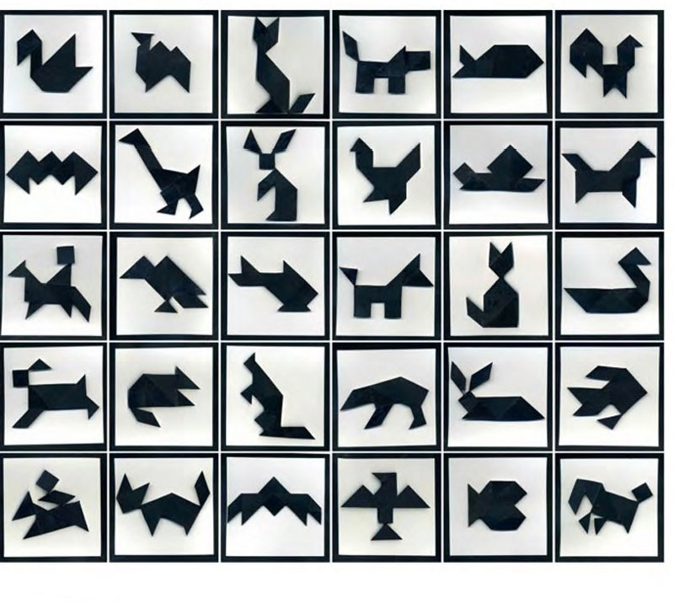

1. Estimate the total area of the shapes to be used.
2. Simplify: $$\frac{20}{21}÷\frac{30}{5}$$
3. Round to the nearest whole number:
$$\frac{25}{4}$$

4. Combine like terms and solve for $x$.
$$-4x+16-6x=46$$

5. Evaluate:

$${\left(\frac{-8}{9}\right)}^{2}$$