Nascar Racing with Calculators

Ever want to experience being the crew chief of your own NASCAR team? Well, now you can! Using your TI-83 or TI-84 as the driver, you and your team provide the instructions to your driver to direct the car around any course you want. Here are some commands that will help direct your car wherever you want to go:
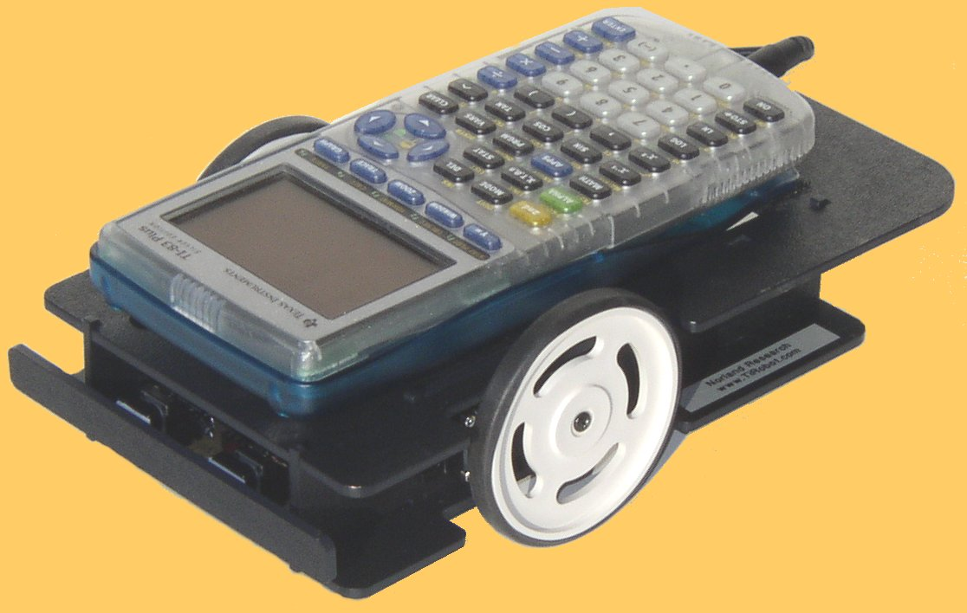

Command
1 = Timed Movement Only
2 = Front Switch is Hit
3 = Time or Switch

Left Wheel
0 = Backward
1 = No Motion
2 = Forward

Right Wheel
0 = Backward
1 = No Motion
2 = Forward
The first number sent is the command. The movement commands format is CLR. Where C is the command, L is the direction of the left wheel, and R is the direction of the right wheel.

Format for CLR:
C = Command
L = Left
R = Right

Format for C:
1 _ _ executes time movement
2 _ _ executes command until front bumper is hit
3 _ _ executes command until from bumper is hit or time

Format for L or R:
0 = Backwards
1 = No Motion
2 = Forward

How to attain these functions (For the TI-83/84 Plus)
- Press the PRGM button
- Scroll over to NEW and hit ENTER
- CREATE NEW
- Make a name for your PROGRAM
- After you create a program, exit out of PRGM menu.
- Enter back into PRGM and scroll over to EDIT and hit ENTER on your new PROGRAM.
- Once in EDIT menu, hit PRGM button again and scroll over to the I/O menu.
- Scroll down to B:Send( button and hit enter.
- Enter command and when done with command hit ENTER.
- Hit PRGM button again and scroll over to the I/O menu.
- Scroll down to A:Get( button and hit ENTER.
- Exit out of PRGM menu again so you are on your home screen.
- Hit PRGM button and go to EXEC. Hit ENTER on your program. Your screen should read prgm(and your prgm name). Hit ENTER again to EXECUTE your command.

Now you can successfully enter in your commands to control your robot race car.
Examples:
:Send({122,500})
:Get(R)
(The car will move in a straight line for approximately 5-seconds)

:Send({221})
:Get(R)
(The car will rotate until the front bumper contacts are hit)

:Send({122,500})
:Get(R)

:Send({120,050})
:Get(R)

(This will move the car along a straight line for approximately 5 seconds and then make close to a 90$°$ right hand turn)
Try on your own!
Can you get your robot car to move along a square track?

For the more advanced:
Can you make your robot car move along the sides of a 3-4-5 triangle?

