Math Tailgate

Description:
This activity has students answering questions from several different content areas of mathematics. These include area, fractions, operations with integers, and simplifying expressions. There will be 5 questions in each round and the number of correct answers is the number of attempts you will receive.
Materials Needed:
- Ladder Golf set
- Football
- Hula-hoop
- Putt-putt hole
- Putter and golf balls
- Worksheets of problems
- Plastic cups
- Glass bowls
- Fish
- Ping-Pong balls
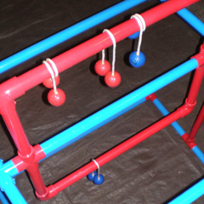
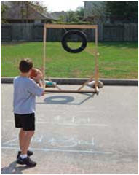
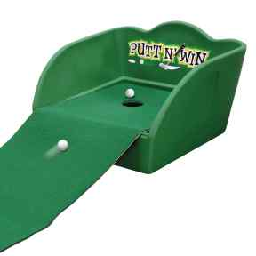

Directions:
- There are five questions in each round.
- Each round has a minute and a half time limit to answer questions and two minutes for the activity.
- The number of questions correct dictates the number of attempts you receive.
- Activity one is golf, two is football, three is ladder golf and four is Fish pong.
- A hole in one receives 10 points, the ladder points are 1,3 and 5, and the distances for football are worth 2, 4 and 6 points, and the cups are worth 5 and the bowls are worth 10 points.
- Each member of the team with the largest total number of points will receive a fish.
- The overall winners receive the Mathematics Lombardi Trophy!

Round 1
Find the area of the following rectangles
7 cm
8 cm
6cm

14 cm
8 cm
14cm

Round 2
Write each fraction in reduced form

Round 3
Perform the following operations

Round 4
Simplify the following expressions.

1)224 2)104 3)98 4)36/7 5)39/7 6)4/9 7)5/9 8)2359 9)1557 10)243 11)625 12)33/7 13)11 14)18 15)9

