Nicole Calbi, Ashely Kowal, Angela Watson, Mark Heiler
Math Taboo!
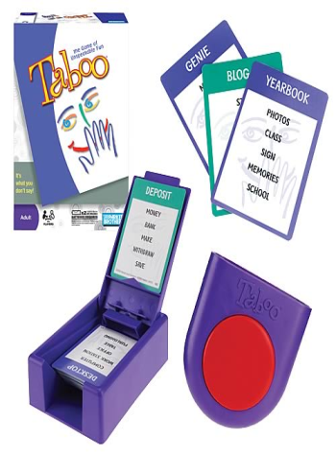

Intro:
Partners will have to be in sync with each other and think quickly to guess as many math vocabulary words or numbers as possible! Your partner will describe a vocabulary word to you with a few restrictions of what they can say. You will get points for each vocabulary word you are able to guess.
Materials:
- Vocabulary cards
- Sand timer
- Buzzer
- Scoreboard
- Pencil
- Bracket

Directions:
- Parents and their child are partners
- Teams can be anywhere from 2-4 people
- One partner will get the word and have to describe to their partner without saying the actual word or any of the restrictions on the card
- 3 rounds to face another team
- Each round will be timed with a 30 second hour glass
- You get fake money for each correct vocabulary term you guess correctly
- The team with the most money at the end of the round gets spends their money on a prize
- The team with the GRAND total at the end of all rounds will get the grand prize!

Sample Problems
Slope Denominator
Rise Bottom
Run Line
Divided Number
Steep Fraction

Obtuse Angle Negative Number
Angle Less
Between 0
90 Positive
180 Real

You are trying to get your teammates to say the top word, however you cannot use any of the words on the card in your description.

