Stump The Chump
Introduction:
This “lesson’s” purpose is to explore different questions that may come up in a typical classroom that student’s may ask. Answers that teachers may respond with often include “it’s a rule” or “it’s a law” either because for the moment they may be stumped, or they feel it will take too long to explain an entire proof. This lesson gives a couple quick proofs that are handy and easy for students to understand.
Standards: (NYS P-12 Common Core Learning Standards for Mathematics)
A.PS.3: Observe and explain patterns to formulate generalizations and conjectures
A.RP.8: Support an argument by using a systematic approach to test more than one case
A.CM.5: Communicate logical arguments clearly, showing why a result makes sense and why the reasoning is valid
A.CN.8: Develop an appreciation for the historical development of mathematic
A.N.6: Evaluate expressions involving factorial(s), absolute value(s), and exponential expression(s)
G.RP.6 | Evaluate written arguments for validity

Objectives:
The objective intended for this lesson is to have a couple easy explanations for questions that students often ask in the classroom. After the students are presented with these ‘proofs’, they should have an understanding of why some mathematics concepts are the way they are instead of having the memorize a ‘rule’.

Why is any number raised to the zero power equal to one?
Let's first look at an example. Let's look at the list of numbers $3^{1} , 3^{2} ,3^{3} { ,3}^{4}$

$3^{1} 3^{2} 3^{3} { 3}^{4}$
Finding the actual values, we get $3 9 27 81$

So what is the pattern in the bottom sequence? Every time you move to the right in the list you multiply by 3, and every time you move to the left in the list you divide by 3. So we could take the bottom sequence and keep going to the left and dividing by 3, and we'd have the sequence that looks like this:
$$… 3^{-3} 3^{-2} 3^{-1} 3^{0} 3^{1} 3^{2} 3^{3} 3^{4} ....$$
$$… \frac{1}{27} \frac{1 }{9} \frac{1}{3} 1 3 9 2 81 ....$$

So now we know what all the powers of 3 are! Actually, we just did the integer powers of 3 but that's sufficient enough to get the point across.

While the above argument might help convince your intuitive side that any number to the zero power is 1, the following argument is a little more rigorous.
This proof uses the laws of exponents. One of the laws of exponents is, provided $b≠0$:
$\frac{b^{x}}{b^{y}}=b^{x-y}$ or $b^{x}b^{y}=b^{x+y}$
For example:
$$b^{0}\left(b^{1}\right)=b^{0+1}$$

$$b^{0+1}=b^{1}$$

Or you can rearrange the terms to get:

$$b^{0}=\frac{b^{0+1}}{b^{1}}$$

$$b^{0}=\frac{b^{1}}{b^{1}}$$

This fraction equals 1, because the numerator and the denominator are the same. So,
$$\frac{b^{1}}{b^{1}}=1=b^{0}$$

Why does 0! = 1 ?
Usually $b$ factorial is defined in the following way:
$$b! = 1*2*3*...*b$$
But this definition does not give a value for 0 factorial, so a natural question is: what is the value of $0!$ ?
A first way to see that $0! = 1$ is by working backward. We know that:
$$1! = 1$$

$$2! = 1!*2=2$$

$$3! = 2!*3=6$$

$$4! = 3!*4=24$$

We can turn this around: $4! = 24$
$$3! =\frac{4!}{4}=6$$
$$2! =\frac{3!}{3}=2$$
$$1! =\frac{2!}{2}=1$$
$$0! =\frac{1!}{1}=1$$

Why can't you divide by 0?

Provided you aren’t dividing zero by zero, (this form would also be indeterminate) division by zero is an operation for which you cannot find an answer, so it is disallowed, or undefined. You can understand why if you think about how division and multiplication are related.
12 divided by 6 is 2 because 6 times 2 is 12
$$\frac{12}{6}=x$$

$$12=6x$$

$$x=2, 12=6*2$$

12 divided by 0 is $x$ would mean that 0 times $x$ = 12

But no value would work for x because 0 times any number is 0. So division by zero doesn't work.
$$\frac{12}{0}=x$$
$$12=0x$$

Anything times 0 is 0, therefore there is no solution.

Why is there $360°$ in a circle?
While we aren’t fully certain of the answer, mathematic historians have come up with plausible reasoning. One of these reasons, for example has to do with the fact that the Babylonians used base 60, but this is not a very convincing argument standing alone.
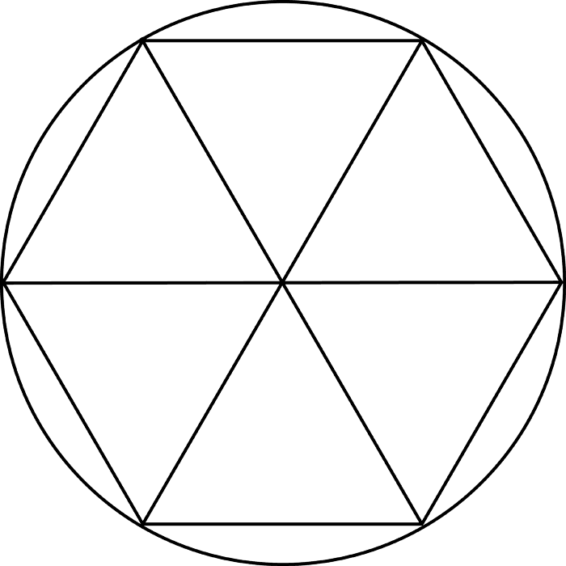
Here, we have a hexagon inscribed in a circle. This splits the hexagon into 6 equal parts. The Babylonians may have picked a hexagon because the length of one edge of the hexagon is exactly equal to the length of the radius. Then, with the knowledge that the Babylonians used base 60, they split each portion of the hexagon into 60 equal parts, and 6 times 60 is 360, hence 360 degrees in a circle! Cool huh?

Here are some of my favorite websites that I like to use for some quick proofs of “Stump the Chumps”
- www.mathforum.org
- www.scienceforums.net
- www.mathmojo.com
- www.teachertube.com
Also, here are some more “Stump the Chumps” that I came across:
- Is 1 prime?
- What is an imaginary number?
- Is infinity a real number?
- Where does the quadratic formula come from?
- Why is a positive number times a negative number a negative number?

