Bull’s Eye
With teams made up of 3-4 students, each team will be given a set of cards. Using these cards, the teams must use any combination of operations to come up with one of the “target numbers,” which are preselected by the judges.
How to Play:
- To start, cards will be revealed to both teams simultaneously. Each team tries to combine the numbers to make one of the three chosen “target numbers."

- Players may use exponents, as well as add, subtract, multiply, and divide, the numbers in any order, but they may not put two cards together to make a two-digit number.

- Each card may be used only once in the calculation.
**Note: Aces can be used as a 1 or 11. All face cards have a value of 10.

Other specifications:

- Each team will be given 5 cards to start. The target numbers will then be revealed. Before the round starts, each team will remove one card from the opposing team’s set of cards.

- There will be one point awarded to the team that wins each round. There will be a grand prize winner at the end of the night as well as winners for each rotation.

- Each team will be given white boards for calculations.
- When a team has figured out a way to make the target number, an individual from that team must explain their solution to the judge.
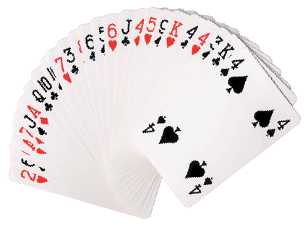

Sample Problems:
- Target #: 12  Cards Given: Ace, 7, 8, 10 | - Target #: 72  Cards Given: Ace, 8, 2, 9
- Target #: 40  Cards Given: 10, 4, 3, 7, 6 | - Target #: 25  Cards Given: 6, 8, 2, 3
- Target #: 36  Cards Given: 6, 3, 9, 4 | - Target #: 51  Cards Given: 6, 7, 8, Ace
