**Folding and Fractions with Fujimoto**

Materials

* Four 10” by 2” strips of paper
* One 4” square
* One place mat for the folded pieces of paper

**Step 1.** Given a strip of paper 10” by 2” try to fold it exactly in half. Easy right?

**Step 2.** Take another strip of paper and fold it into exact fourths. Still too easy?

**Step 3.** Try to take a third strip of paper and fold it into exact fifths. Write down the steps you took to fold your strip of paper into fifths.

______________________________________________________________________________________________________________________________________________________________________________________________________________________________________________________________________________________________________________________

Now that we have applied Fujimoto’s method, measure your approximate one fifth. How close to an actual fifth do you get? (That is how close to 2 inches are you?)

**Step 4.** Using Fujimoto’s approximation method, can you approximate a seventh? In step three we had pinch marks at , where are the pinch marks on the paper when approximating a seventh?

____________________________________________________________________________________________________________________________

**Step 5.** Now let’s look at a third. Can you see how to approximate a third using the 4” square piece of paper? Briefly explain.

______________________________________________________________________________________________________________________________________________________________________________________________________________________________________________________________________________________________________________________

**Step 6.** Finally, provided we can fold a third, what is a simply way you could fold a sixth? ________________________________________________________

_____________________________________________________________

_____________________________________________________________

**Solutions**

**Question 3**

(1) Make a guess pinch.

(2) To the right of this guess is ≈ 4/5 of the paper. Pinch this side in half.

(3) That last pinch is near the 3/5 mark. To the right of this is ≈ 2/5 of the paper. Pinch this right side in half.

(4) Now we have 1/5 mark on the right. To the left of this is ≈ 4/5. Pinch this side in half.

(5) This gives a pinch nearby the 2/5 mark. Pinch the left side of this in half.

This last pinch mark will be very close to the actual 1/5 mark!

(1)

(3)

(5)

(4)

(2)

Question 4

You will get pinch marks at approximately 1/7, 4/7, and 2/7.

Question 5.

Given a square, ABCD, we can fold it into thirds.

Proceeding:

1. 
2. 
3. 
4. 







Refer to figure 9.

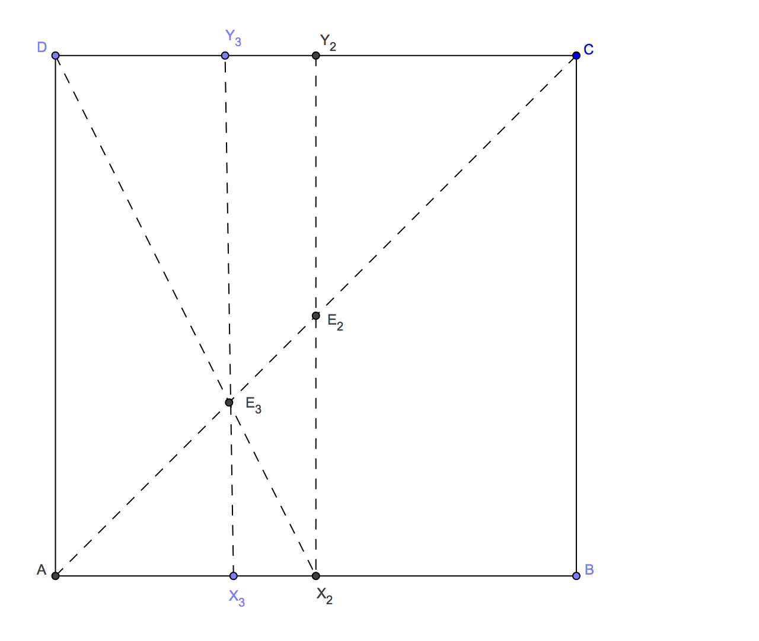

**Figure 9**

Proof that our method for number 5 works.

Assume that the square has side length one. Denote the coordinates of E3 with (x,x). Then line segment CY3 has length x, so segment Y3D has length 1-x. Also segment Y3E3 has length x.

Then Δ DY2X2 and Δ DY3E3 are similar. Thus , which becomes



Question 6

Students should be able to see that you can obtain a sixth by folding a third in half.

Hull, Thomas. Project Origami, Activities for Exploring Mathematics. Massachusetts: AK Peters, 2006.