Kyle Erlandson Andrew Carucci
kerlandson@fredonia.edu acarucci@fredonia.edu

SUNY Fredonia AMTNYS Presentation: Proportional Reasoning

Pizzas, Trains, and Proportional Reasoning
The following lesson is intended for 7th-8th grade students. It presents problems which involve linear measurements, area, and volume. Students will explore the relationship between doubling the diameter of a circle and its resulting area and apply this concept to volume measurements. At the conclusion of this lesson, students will have a better understanding of proportional reasoning.

Professional Standards Addressed:
This lesson addresses the following NYS MST Standards/Performance Indicators and the Common Core State Standards (CCSS) in mathematics:
- 8.PS.10 Use proportionality to model problems.
- 8.M.1 Solve equations/proportions to convert to equivalent measurements within
metric and customary measurement systems.
- 7.RP.1 Compute unit rates associated with ratios of fractions, including ratios of
lengths, areas and other quantities measured in like or different units.
- 7.RP.3 Use proportional relationships to solve multistep ratio and percent
problems. Examples: simple interest, tax, markups and markdowns.

Instructional Objectives:
At the conclusion of this lesson, students should be able to:

- Determine the final height of the One World Trade Center given the height of the now 75% completed tower.
- Apply proportional reasoning to determine the relationship between a circle and its resulting area after the diameter has been doubled.
- Use proportional reasoning to determine whether a scale model train would weigh more or less than the actual train if it were proportionally expanded to the same dimensions.

Instructional Protocol/Itinerary:
- Present a linear proportion problem which finds the final height of the One World Trade Center, formally known as the Freedom Tower.
- Determine whether two personal pizzas or one medium pizza is the better buy.
- Determine whether a scale model of a train weighs more or less than the actual train.
- Discuss the impossibility of giant spiders.

Do Most Students Actually Understand Proportions?
Students are often asked to solve problems which do not correlate with real-life situations. For example, every student has been asked to solve some version of the following problem:

Find 75% of 500.
Most students would be able to solve this problem by changing the percent to a decimal, then multiplying the two numbers to come up with an answer of 375. Most students have done enough of these types of problems that they can perform the calculations and come to a correct answer without reflecting on what their answer really means.
Now let’s look at a problem that will test students’ knowledge instead of using automaticity through the use of a calculator.
The One World Trade Center, formally known as the Freedom Tower, is due to be completed by the end of 2012. Right now it stands at a height of 1,026 feet, which is 75% of the building’s final height. How tall will the One World Trade Center be when completed?

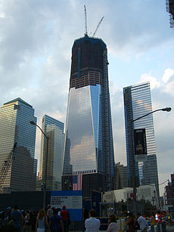

Here we have a slightly different problem which requires students to think strategically. Most students have been taught the formula:

Whole $×$ Percent $=$ Part of the Whole

We now will teach students how to manipulate this formula to create the proportion:

$$\frac{\text{Whole}}{1}=\frac{\text{Part} \text{of} \text{the} \text{Whole}}{\text{Percent}}$$

This is not a formula that would be intuitive to most students.

Finally, since we were originally given the Part of the Whole and the Percent, we can calculate the final height of the One World Trade Center:

$$\text{Whole}=\frac{1,026 \text{feet}}{.75} = 1,368 \text{feet}$$

The One World Trade Center will be 1,368 feet when it is completed.

Since this problem has a real-life correlation, students should be able to better reflect on their answer. For instance, a student should see that something is wrong with their final answer if it is less than 1,026 feet since the tower has only reached 75% of its final height when it is at 1,026 feet; so the completed tower will obviously be greater than 1,026 feet.

A Pizza Proportional Project

The following question can become a project which teaches and reinforces area proportions:
Neal and Del go out to Pizza Hut for dinner. While they are preparing their order, they get into an argument about which type of pizza to get. They see that a 6 inch personal pizza costs $3.79 and a 12 inch medium pizza costs $10.99. Del thinks they should just buy two personal pizzas ($7.58) which would be cheaper than one medium pizza ($10.99), but Neal thinks they should split the medium pizza. Which of these two scenarios is the better buy? What do you think your students would say?

Medium Pizza (12 inches)
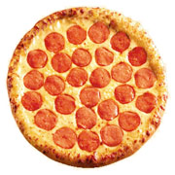
Personal Pizza (6 inches)

Many students (and some adults) will intuitively think that the two personal pizzas is the better buy, since two personal pizzas cost less than one medium pizza. However, when the diameter of a circle doubles, the area of that circle actually quadruples. Since this may be a difficult concept for students to understand initially, let’s investigate this problem in greater depth.
To help students grasp this concept, we will give students a poster board with circles to cut out. Students can measure each of these circles. The sheet will have five circles, four with a diameter of 6 inches and one circle with a diameter of 12 inches. Students can cut out these circles to see that three of the 6-inch circles can fit into the one 12-inch circle with some room to spare. Challenge students to see if they can fit all four 6-inch circles inside the 12-inch circle. By completing this project, students will be able to see that doubling the diameter of a circle does in fact quadruple the area of the resulting circle.
This project will show students that three 12-inch pizzas ($11.37) have less area that one 12-inch pizza ($10.99). This means that the one 12-inch pizza is in fact the better buy.

Lastly, students can mathematically analyze this problem by computing the area of each pizza:
Area of the 6 inch pizza $= 9π \text{i}{\text{n}}^{\text{2}}$ Area of the 12 inch pizza $= 36π \text{i}{\text{n}}^{\text{2}}$
Thus, the area of the 6 inch pizza quadruples when we double its diameter/radius. However, the price of the 12-inch pizza is not even three times the cost of the 6-inch pizza. Therefore, the 12-inch pizza is clearly the better buy.

This same concept can also be visually shown using a square

If we double the sides of this square, we can see that the area of the resulting square quadrupled:

Training to Think Proportionally
This next question will test students’ ability to think proportionally about volume and weight.
We have a $\frac{1}{87}$ scale model of a GP38-2 locomotive. This means that the real locomotive is 87 times as long, 87 times as tall, and 87 times as wide as the scale model. The model train weighs about 14 ounces. The real GP38-2 weighs 250,000 pounds. If we were to proportionally expand the scale model to have the same measurements of the real train, which train would weigh more: the model train, the real train, or would they weigh the same?

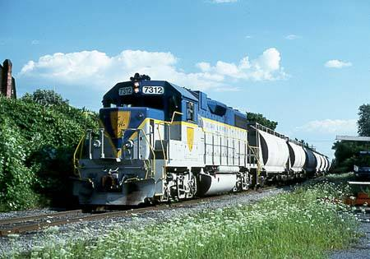

To answer this question, students must realize that to proportionally expand the $\frac{1}{87}$ scale model to the dimensions of the real train, we must expand its length, width, and height 87 times. Therefore, the weight of the model train proportionally expanded would be:
$$14 \text{ounces} ×{87}^{3}=9,219,042 \text{ounces}$$
Then students must be able to convert ounces to pounds:
$$9,219,042 \text{ounces} ×\frac{1\text{ pound}}{16 \text{ounces}}= 576,190.125\text{ pounds}$$
So the model train would weigh $576,190.125$pounds, which is twice the weight of the real train.

Can Giant Spiders Exist in Real-life? (Proportionally Speaking)

Lastly, to have some fun with our students we can examine some ridiculous questions, like the existence of giant spiders, and justify an answer using proportional reasoning.

In order to justify that a giant spider (which is proportional to an actual spider) cannot exist in real-life, we need some proportional reasoning about area and volume. The leg strength of a spider is determined by the cross section of a spider’s leg. Therefore, if we proportionally expanded a spider, its leg strength would only increase by a power of two. However, the spider’s weight is determined by its volume, so the weight of the spider increases by a power of three. This makes the spider too heavy to be supported by its legs. Therefore, giant spiders cannot exist in real-life.
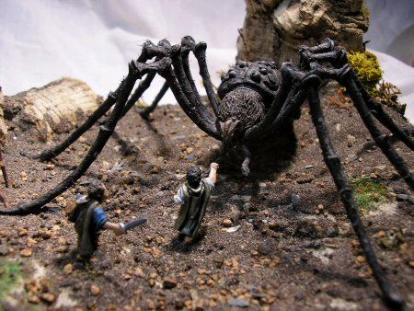

Relevant Resources:
http://en.wikipedia.org/wiki/One_World_Trade_Center
http://www.cheesepizzaguru.com/Menu_Prices.html
http://www.mithril.ie/FanPaintings/Simonetti/index.html
http://www.thedieselshop.us/Data%20EMD%20SD50.HTML

