James Matte Nicole Calbi
JMatte@fredonia.edu NCalbi@fredonia.edu
Integrating Technology: I’ve Got an App For That!
Introduction:
This lesson is intended to give an overview of different Apps for the Apple iPad that can be used in the mathematics classroom. We offer a basic introduction to Wolfram Alpha and how it can be used in the classroom. After researching many apps that are related to mathematics concepts, we narrowed them down to three main applications. Some factors we considered were price, benefits for the students and a mathematics classroom in general. Each app is then compared to the capabilities of the TI graphing calculators. The applications that are shown in this lesson are Wolfram Alpha Course Assistant, Math Pro, and Algebra Touch. At the end of the lesson, the reader can find descriptions of three more Apps that can be used in the classroom.
Standards:
- A.PS.1 Use a variety of problem solving strategies to understand new mathematical concepts
- A.CM.4 Explain relationships among different representations of a problem
- G.PS.3 Use multiple representation to represent and explain problem situations
- G.PS.5 Choose an effective approach to solve a problem from a variety of strategies
- A2.PS.2 Recognize and understand equivalent representations of a problem situation or a mathematical concept
- A2.CN.2 Understand the corresponding procedures for similar problems or mathematical concepts
Instructional Objectives:
Following the conclusion of the lesson, students should be able to:
- Have a better overview of the applications given in this lesson and be able to access them
- Use the Apps effectively in a mathematics classroom
- Know the benefits that students can gain by using these applications and know when/where the Apps will be appropriate to use
- Compare the applications in iPad to the TI calculators that are used throughout various mathematics lessons.
Instructional Protocol/Itinerary:
This lesson is given in a 10-minute presentation. It can be lengthened by having a hands-on workshop with the Apple iPad. The lesson begins by having a PowerPoint that will go through a brief introduction of the program WolframAlpha. It shows how WolframAlpha can be used in a mathematics classroom. The presentation goes over three mathematics Apps. Each Math App gives an introduction on how to use the App, how the App can compare to the TI graphing calculators, and then how the App can be used in a mathematics classroom. At the end of the lesson, there are links to demos of the Apps that are presented. If time permits, we can do a demonstration of the Apps on the Apple iPad.

Wolfram Algebra Course Assistant
This app solves specific algebra problems and often shows how to work through a problem step-by-step. The App can be used in the classroom as review of concepts and material.
Wolfram Algebra Course Assistant can be useful with the following topics:
    - Solving Systems of Equations
    - Factoring Higher Degree Polynomials
    - Finding the Inverse of a Function
    - Dividing any Two Expressions
    - Expanding Polynomials
    - Simplifying Fractions, Square Roots, or Other Expressions
Solve Systems of Equations
Wolfram Algebra Course Assistant can solve a simple equation or a system of equations for specific variables.
Example: Solve $x^{4}-9x^{2}+8=0$ for $x$.
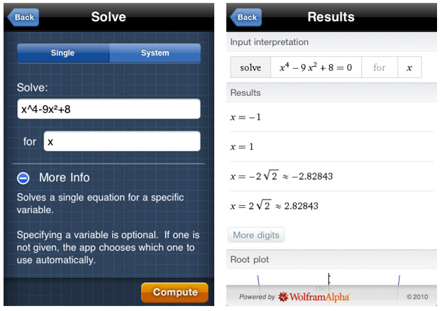
- Wolfram Algebra Course Assistant can solve a single equation or can solve a system of equations given a variable
- The result gives the zeros of the function and thus solving for $x$.
- The App also plots the roots of a given equation on a graph.
Factoring
Wolfram Algebra Course Assistant can factor higher degree polynomials. This app will also give different plots of the function and will show the irreducible factorization of any polynomial.
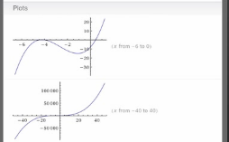
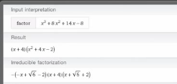
Example: Factor $x^{3}+8x^{2}+14x-8$

Finding the Inverse of a Function
Given a function, Wolfram Course Assistant can find the inverse of a function. It also plots both the original function and the inverse of the function. On the plot, this App shows the line $y=x$ (dotted) on the graph which will demonstrate to students how the inverse function ($f^{-1}(x)$) relates to the original function ($f(x)$).
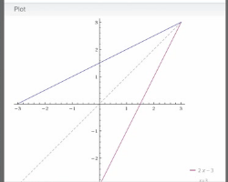
Example: Find the inverse of the following function: $f\left(x\right)=2x-3$
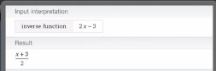

Math Pro
Math Pro explains many of the key concepts that are covered throughout the mathematics curriculum. This app can be used as a resource for students to help them better understand concepts which are confusing to them. The solvers and tutorials add an interactive element for students.
This App can serve as a review for students throughout math courses which can include:
Algebra, Geometry, Probability, Statistics, Trigonometry, and even Calculus
Determinant of a 2x2 Matrix
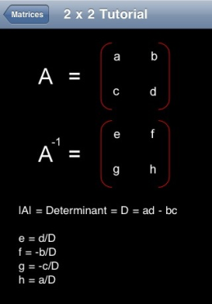
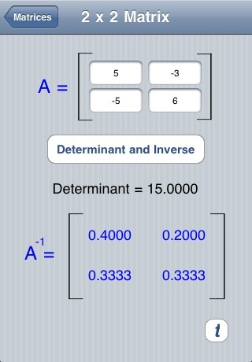
Given a 2x2 matrix, Math Pro can compute and show how to compute the determinant of a function. It can also compute the inverse of a matrix.
- The tutorial helps students better understand how to compute a determinant.
- The App finds the inverse of a given matrix
- It goes through how to compute each entry of the inverse matrix.

Equation of a Line given two points
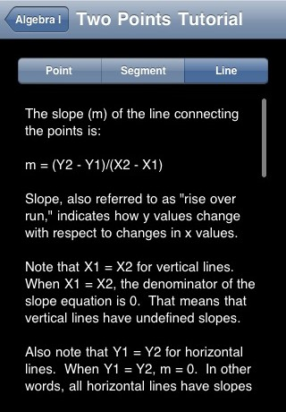
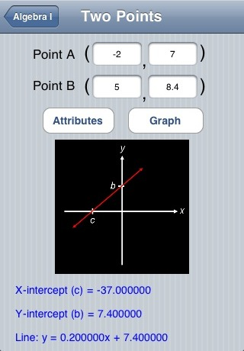
Given two points on a line, this App gives the equation of the line through those two points. It also calculates the $X$-intercept and $Y$-intercept.
- Math Pro gives detailed notes on topics that fit into the math curriculum
- This App could serve as a review for students and can also help struggling students to understand the material.
- Students can compare their classroom notes to the tutorials which can help them better understand the material.
- The tutorial can give students a new perspective on the material that may not have been covered in a given lesson.

Area of Triangles and Circles
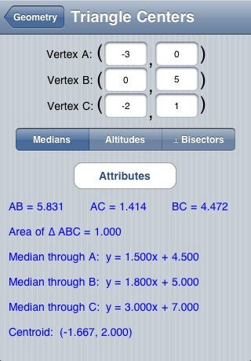
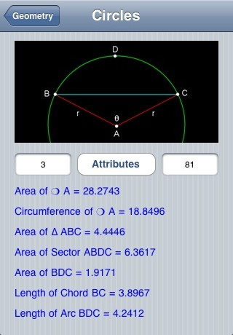
Given three vertices, Math Pro can compute the area of a given triangle and also the lengths of the segments. Math Pro can also compute the area of a circle given its radius.
- Math Pro also finds the circumference of a circle with a given radius
- The App could be used as a way for students to check their work when computing the area of a triangle and a circle
- It also can offer students a review of finding the length of chords of a circle and arc length.

Algebra Touch
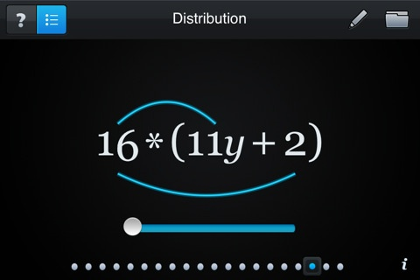
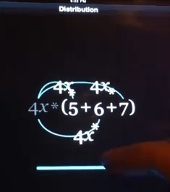
This is a great app to use for beginners in Algebra. It teaches valuable skills while using the correct techniques. The App shows if the correct techniques are used because it will not allow students to do the wrong operations. Students can be gain practice of mathematical concepts by using the randomly generated problems or creating their own. The level of difficulty can be given for the various practice problems. Students are able to drag to rearrange, tap to simplify, and draw lines to eliminate terms.
This App will does things as:
- Simplification
- Commutativity
- Order of Operations
- Distribution
- Factoring
Distribution and Factoring
- Distributing is as easy as sliding the term across the sum
- The App actually shows the process of foiling
- Clicking on the terms will factor them back out

Order of Operations
- Clicking on the operation that comes first will combine the like terms and it will also reduce fractions, if applicable.
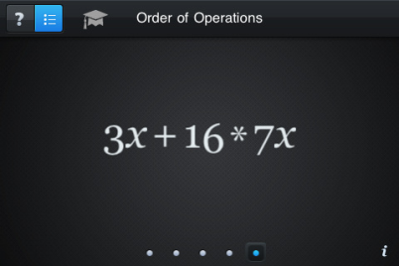
- If a student were to click the wrong operation symbol, the numbers will shake to let the user know that the wrong operation is being used.

Other Math Apps for the iPad:
A great deal can be taught in a mathematics classroom with the aid of the Apple iPad. The Apps that are given in this lesson are just a few of many Apps currently available that can benefit students in middle school and high school mathematics. When researching the Apps, some aspects that were examined were price, benefits for students, and classroom applications.
MathBoard
Spruce up on the simple but important operations. This app quizzes on many aspects of the mathematics curriculum including: addition, subtraction, multiplication, division, squares, cubes and square roots. The range of numbers can be chosen that work the best with a given mathematics problem. The quizzes can be timed and saved. There are math tables for addition, subtraction and multiplication that are quick and easy to access. This app can be very useful in the middle school mathematics classroom. Cost: $4.99
Math Ref
This application is a reference for over 1400 formulas which also includes examples of the equations. This App features the ability to zoom into the equations to get a better look or to project them to show a group of students. It can also group equations into favorites for fast access. This App can be used in any middle school and high school mathematics classroom and even extend to college level classes. Contains equations to many subjects including Algebra, Geometry, Trig, Physics, Calculus, and many more. Cost: $0.99.
MathTerm
MathTerms is an illustrated glossary of mathematics terms that can be used in a middle school or high school mathematics classroom. Definitions of concepts covered throughout the mathematics curriculum can be found using this application. This application includes almost 1,000 terms and definitions. This App can be used in the middle school and high school level mathematics classroom and can also be extended to college level classes. Cost: FREE.
Links to Demos:
Wolfram Algebra Course Assistant: http://www.youtube.com/watch?v=WEWOFUhiXuo
Algebra Pro: http://www.youtube.com/watch?v=A4SdNUwgkcg
Math Pro: http://www.lfeldman.com/mathpro/screenshots (ScreenShots)

