Favorite Foldables
Amber Clavin and Ashley Kowal
aclavin@fredoni.edu and akowal@fredonia.edu
SUNY Fredonia

Table Review
- Begin with one blank sheet of paper (approximately $8.5$by $11$ inches).

- Arrange the sheet so that it lies vertically. Let $A, B, C$ and $D$ be the corners of the paper. From the right side measure over one inch and fold vertically along the segment $\overline{EF}$.

Figure 1
- After the first fold, continue by folding the remainder of the sheet vertically in half along the segment $\overline{GH}$.

Figure 2

- Now creases are to be made horizontally by folding the sheet in half thrice, consecutively without unfolding, so that each eight new rows are made on the sheet of paper in a horizontal manner. The resulting line segments are labeled $\overline{IJ}, \overline{KL}, \overline{MN}, \overline{OP}, \overline{QR}, \overline{ST},$ and $\overline{UV}$. Where each of these line segments intersect the vertical segment $\overline{GH}$, an intersect point is proscribed. These points in vertical order from top to bottom are $W, Z, A_{1}, B_{1}, C_{1}, D_{1},$ and $E_{1}$.

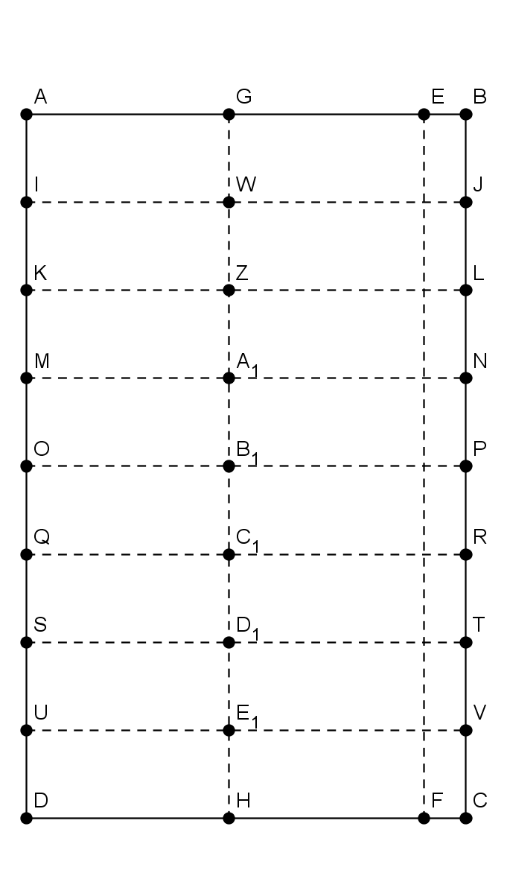
Figure 3

- To finish off the sheet of paper, cuts must be made along each of the following segments: $\overline{IW}, \overline{KZ}, \overline{MA_{1}}, \overline{OB_{1}}, \overline{QC_{1}}, \overline{SD_{1}},$ and $\overline{UE_{1}}.$

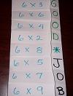

Figure 4

