Favorite Foldables
Amber Clavin and Ashley Kowal
aclavin@fredoni.edu and akowal@fredonia.edu
SUNY Fredonia

Hidden Panel

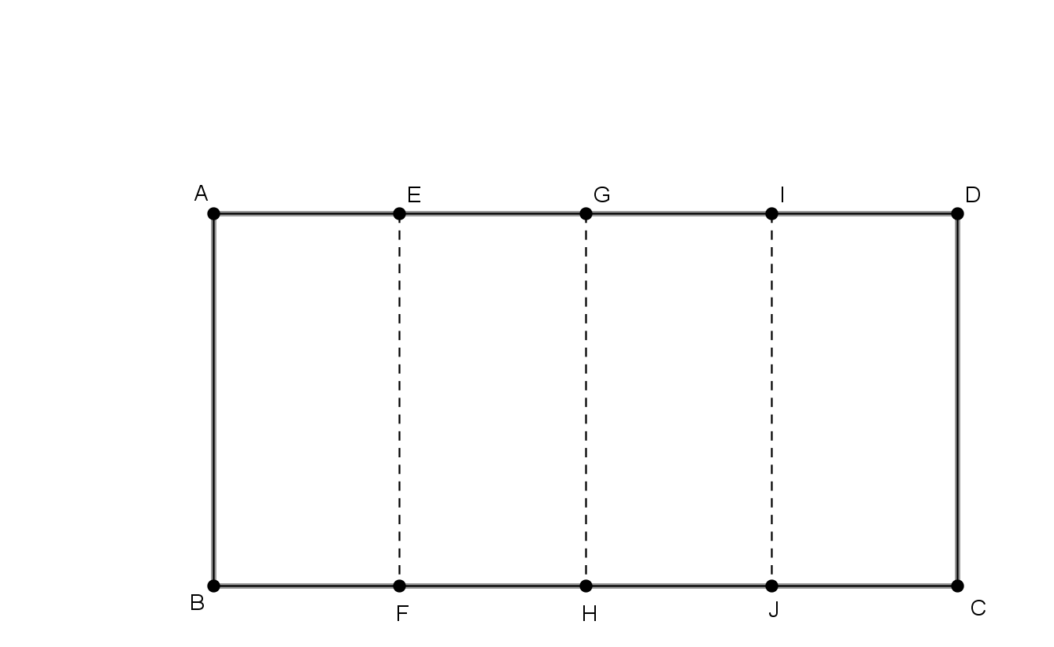
- Begin with two blank sheets of paper (or colored construction paper [you can use two different colors]).

- Take one sheet, and turn it so that it is horizontal. Let $A,B,C,$ and $D$ be the corners. Fold the paper into four equal sections creating segments, $\overline{EF}, \overline{GH, }$ and $\overline{IJ}$ as shown in Figure 1.

Figure 1

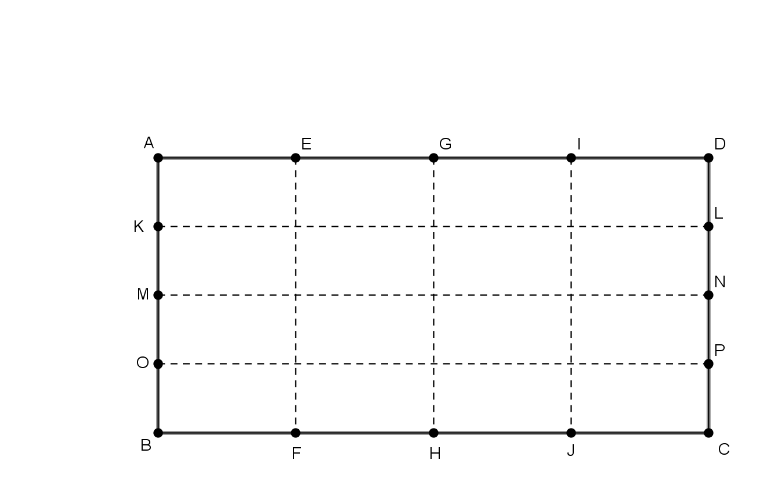
- Depending on the project, we fold the paper into a number of congruent rectangles. For this sheet, we will make 16 congruent rectangles, each similar to the original rectangle. We do this by making creases on the segments, $\overline{KL}, \overline{MN, }$ and $\overline{OP}$. This is shown in Figure 2. This creates 16 congruent rectangles.

Figure 2

- Now fold $\overline{DC}$ over to $\overline{AB}$ along $\overline{GH}$. Then cut along the segments, $\overline{QT}, \overline{RU},$ and $\overline{SV}$, as shown in Figure 3.

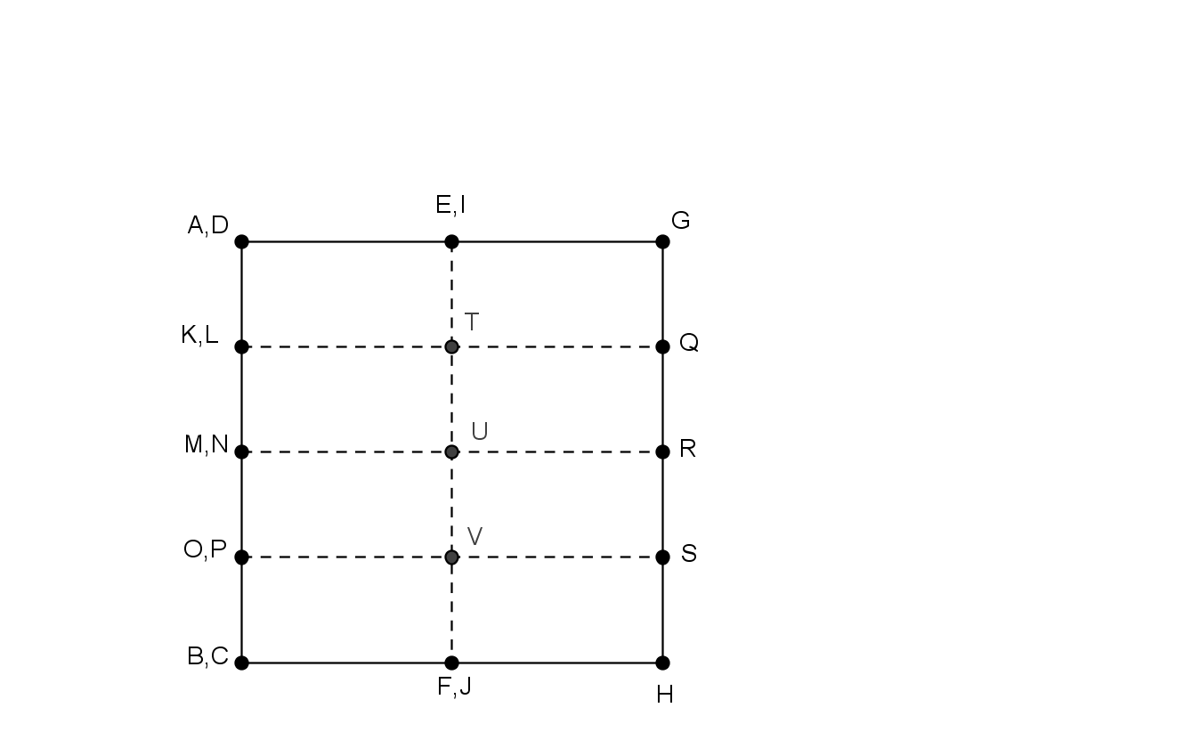

Figure 3

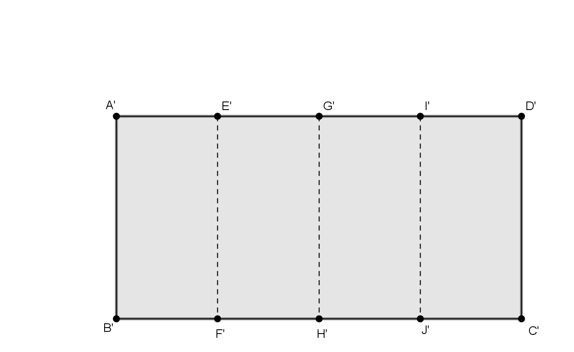
- Take the second sheet of paper and turn it horizontally. Let $A,B,C,$ and $D$ be the corners. Fold the paper in half creating crease at segment, $\overline{EF}$. Then fold that in half creating a crease at segment $\overline{GH}$ as shown in Figure 4. Cut along $E'F'$, $G'H'$, and $I'J'$. Discard the two “end” rectangles. (This is where you can use a different color if you wish.)

Figure 4
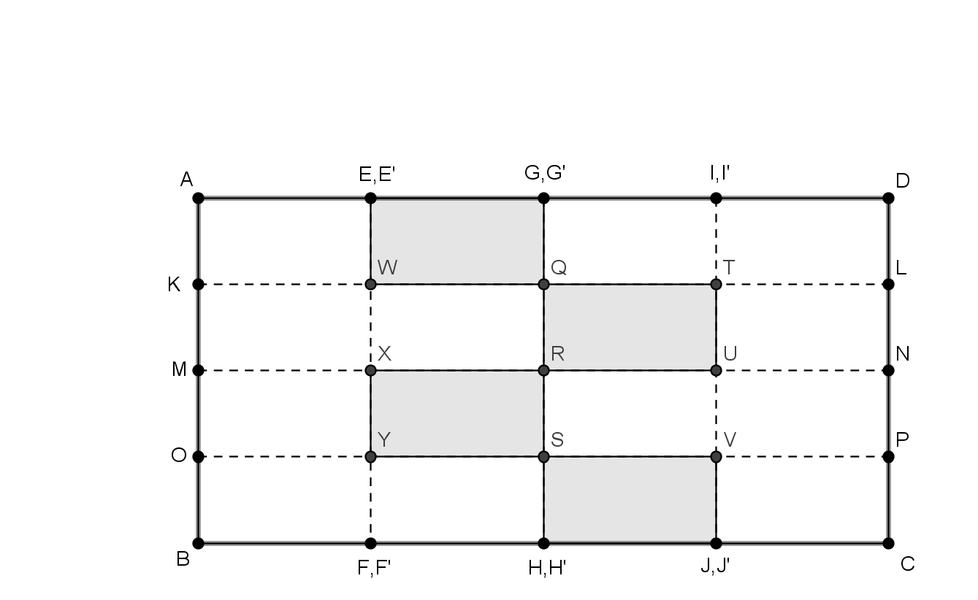
- This is the hardest step. The two quarter sheets must be weaved in to the middle two sections. They should be opposite of each other. This is shown in Figure 5.

Figure 5

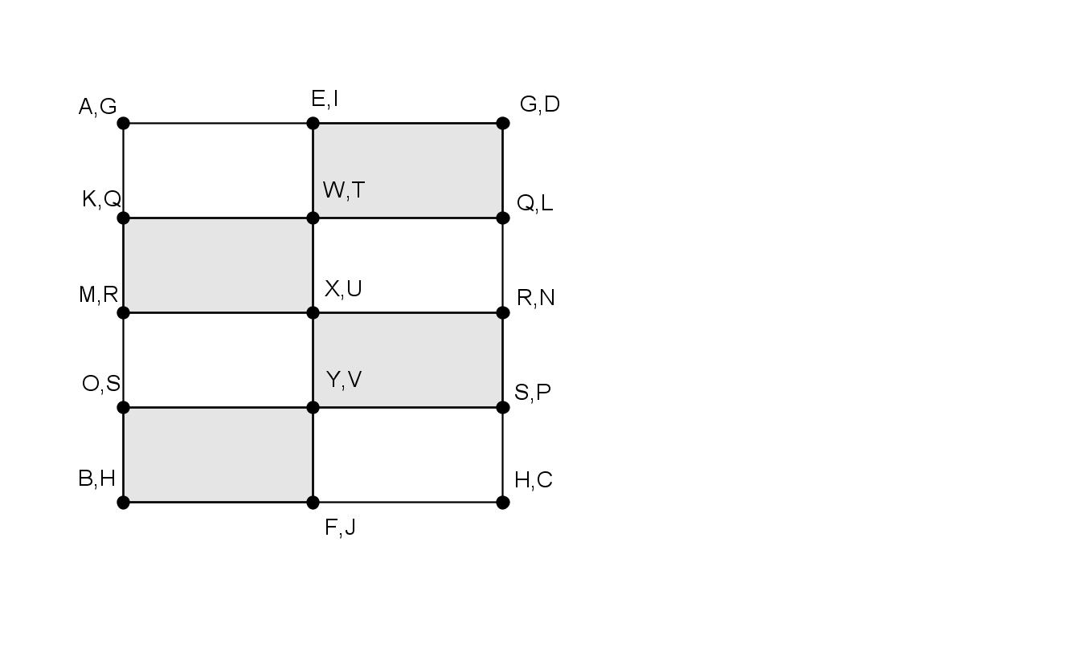
- The hidden panel is found by opening up the middle. You must pull out on segments, $\overline{QR}$ and $\overline{RS}$ in opposite directions. This is shown in Figure 6.

Figure 6

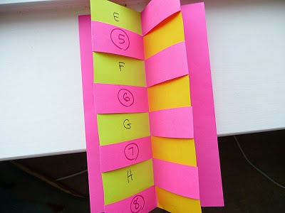

Figure 7

