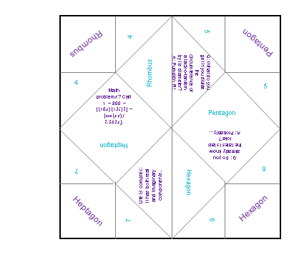

Questions:
- Choose one: Rhombus, Pentagon, Hexagon, or Heptagon
- How many sides does it have?
- Does it have parallel sides? (spell out yes or no)
- How many angles does it have?
Lift it up, and hopefully you have what you picked originally! If not, try again!

