Favorite Foldables
Amber Clavin and Ashley Kowal
aclavin@fredoni.edu and akowal@fredonia.edu
SUNY Fredonia

Fortune Teller

- Begin with a standard sheet of paper (approximately 8.5 ×11 inches seems to work well).

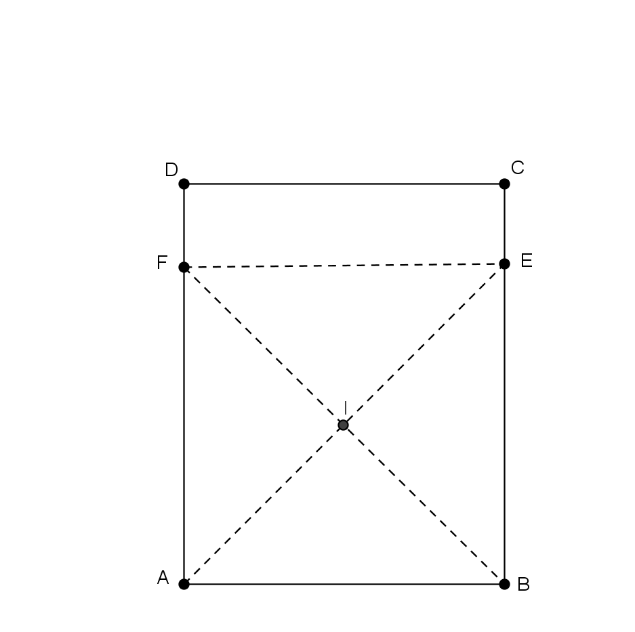
- In order to obtain our desired result of a square, label the vertices of the rectangle $A, B, C,$and $D$ as in Figure 1 below. Fold vertex $A$ to segment $BC$ (denoted by $\overline{BC}$) at point $E$, and unfold, forming triangle $ABF$. Similarly, fold vertex $B$ to segment $AD$ (denoted by $\overline{AD}$) at point $F$, and unfold, forming triangle $BAE$. Make a crease joining points $F$ and $E$, forming $\overline{FE}$, and cut along this segment, forming the square $ABEF$, discarding rectangle $FECD$. $I$ is the center of the square.

Figure 1
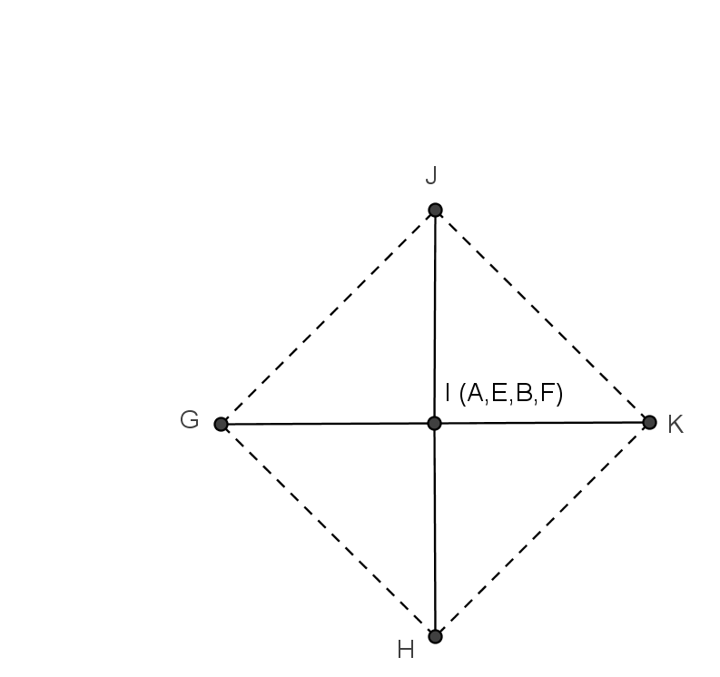
- Fold vertex $A$ to center $I$ creating crease $\overline{GH}$, and vertex $E$ to center $I$ creating crease $\overline{JK}$. Similarly, fold vertex $F$ to center $I$ to create crease $\overline{JG}$, and vertex $B$ to center $I$ to create crease $\overline{KH}$. Don’t unfold any creases. Notice that polygon $GHKJ$ creates another square. This is shown in Figure 2.

Figure 2
- Flip the square over and rotate $90°$. Fold vertex $H$ to center $I$ creating crease $\overline{LO}$, and vertex $J$ to center $I$ creating crease $\overline{MN}$. Similarly, fold vertex $K$ to center $I$ to create crease $\overline{LM}$, and vertex $G$ to center $I$ to create crease $\overline{NO}$. Don’t unfold any creases. Notice that $OLMN$ creates a similar square. This is shown in Figure 3.

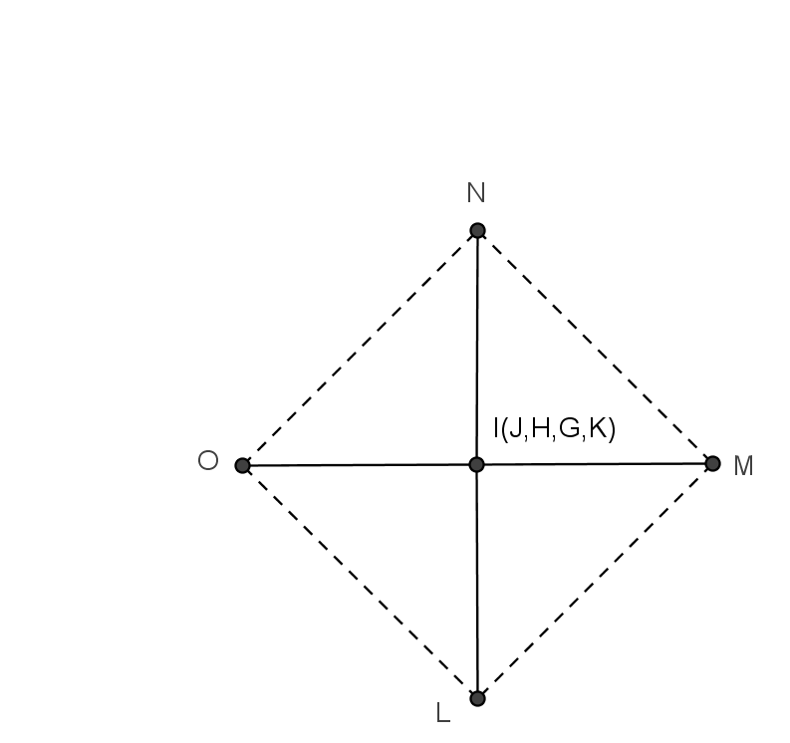

Figure 3
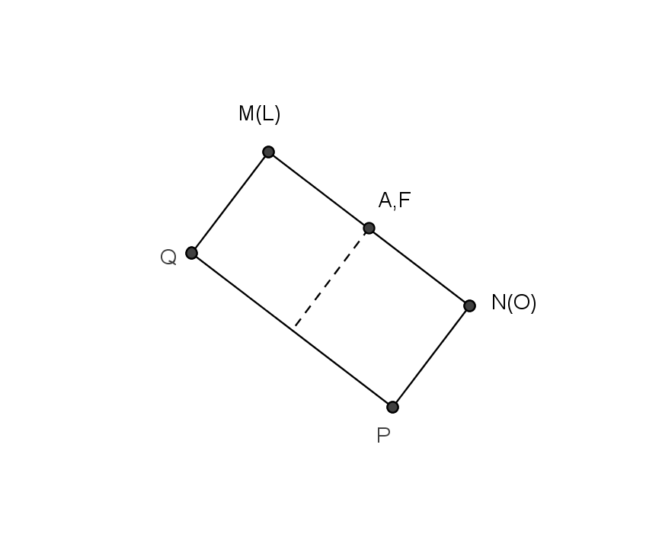
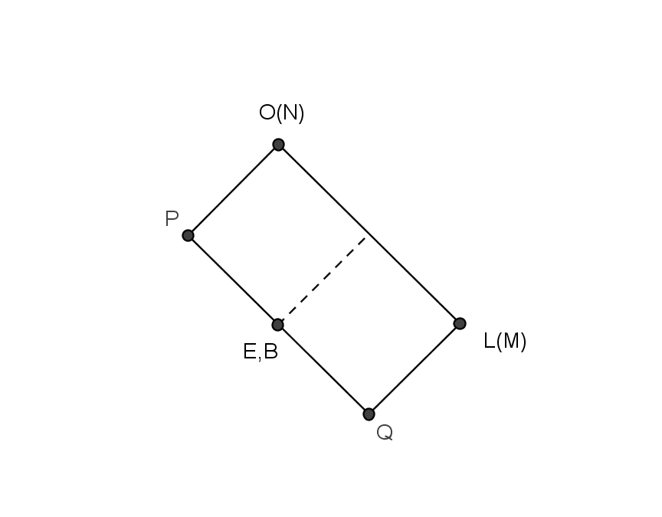
- Fold $\overline{OL}$ to $\overline{NM}$. This forms a rectangle. To open lift pockets E, B, F, A. This is shown in Figure 4.

- (b)

Figure 4

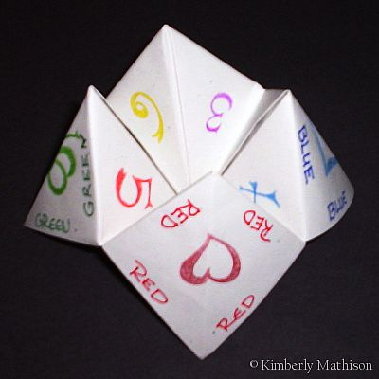

Figure 5

