Favorite Foldables
Amber Clavin and Ashley Kowal
aclavin@fredoni.edu and akowal@fredonia.edu
SUNY Fredonia

Rosette Tea Fold

- Begin with 8 congruent squares of paper (using a side-length of about 4 inches seems to work well).

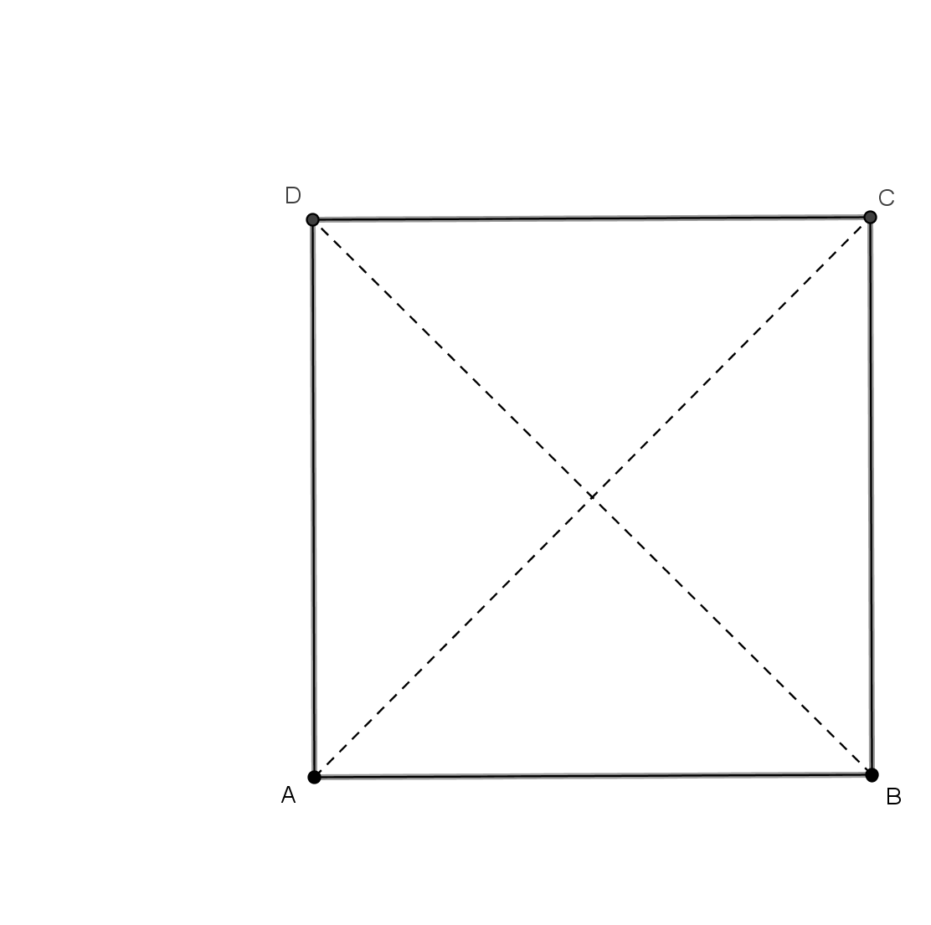
- Take one square of the paper, flip it over to the backside, and label the vertices of the square $A, B, C,$and $D$ as in Figure 1 below. Fold vertex $B$ to vertex $D$, and unfold, creating the valley fold crease $\overline{AC}$ . Similarly, fold vertex $A$ to vertex $C$, and unfold, creating the valley fold crease $\overline{BD}$ .

Figure 1
- Fold segment $DC$ (denoted by $\overline{DC}$) to segment $AB$, and unfold, creating the mountain fold crease$\overline{EF}$ . Note that line $EF$ is the horizontal axisof symmetry of the square. Let $I$ denote the midpoint of $\overline{EF}$. Note that $I$ is the center of the square. This is shown more explicitly in Figure 2.

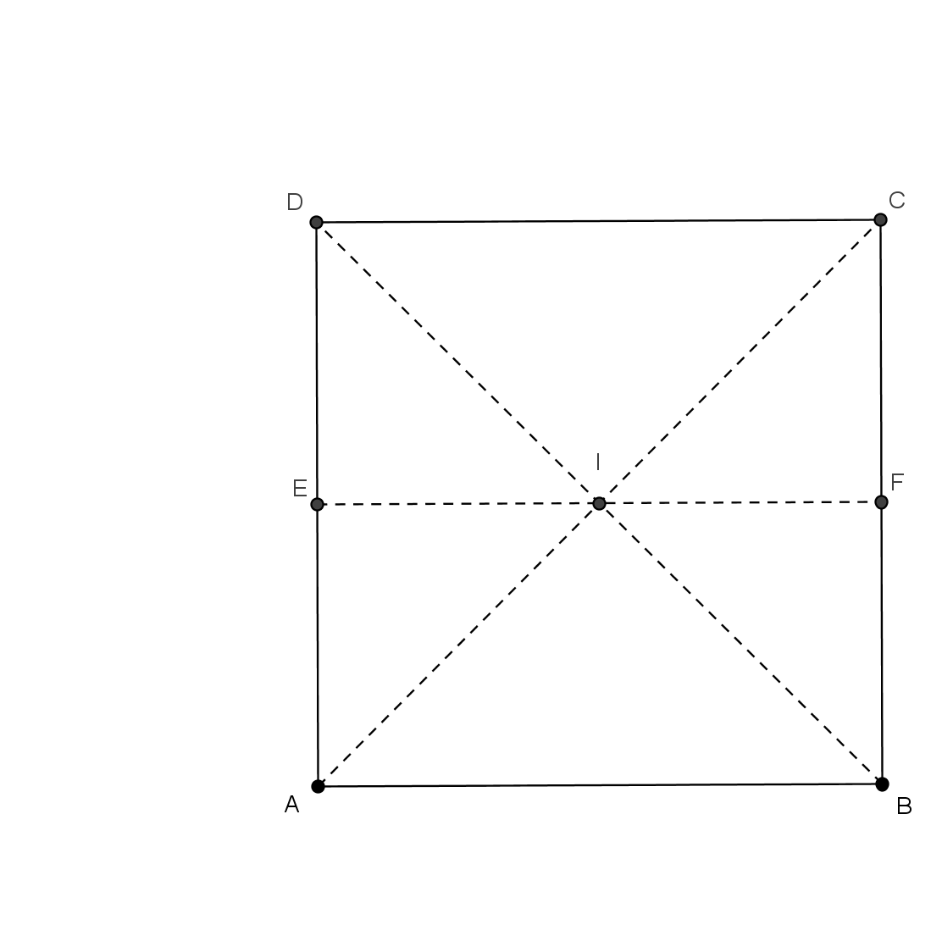

Figure 2
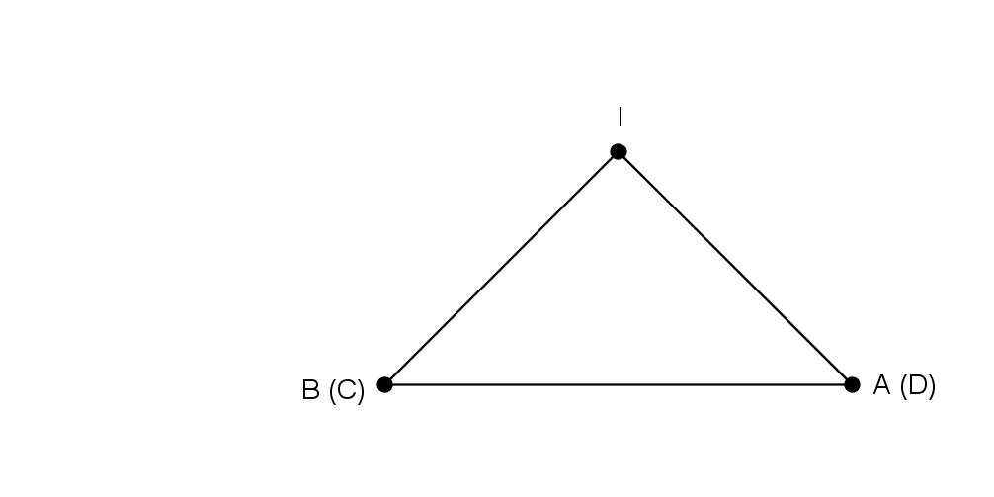
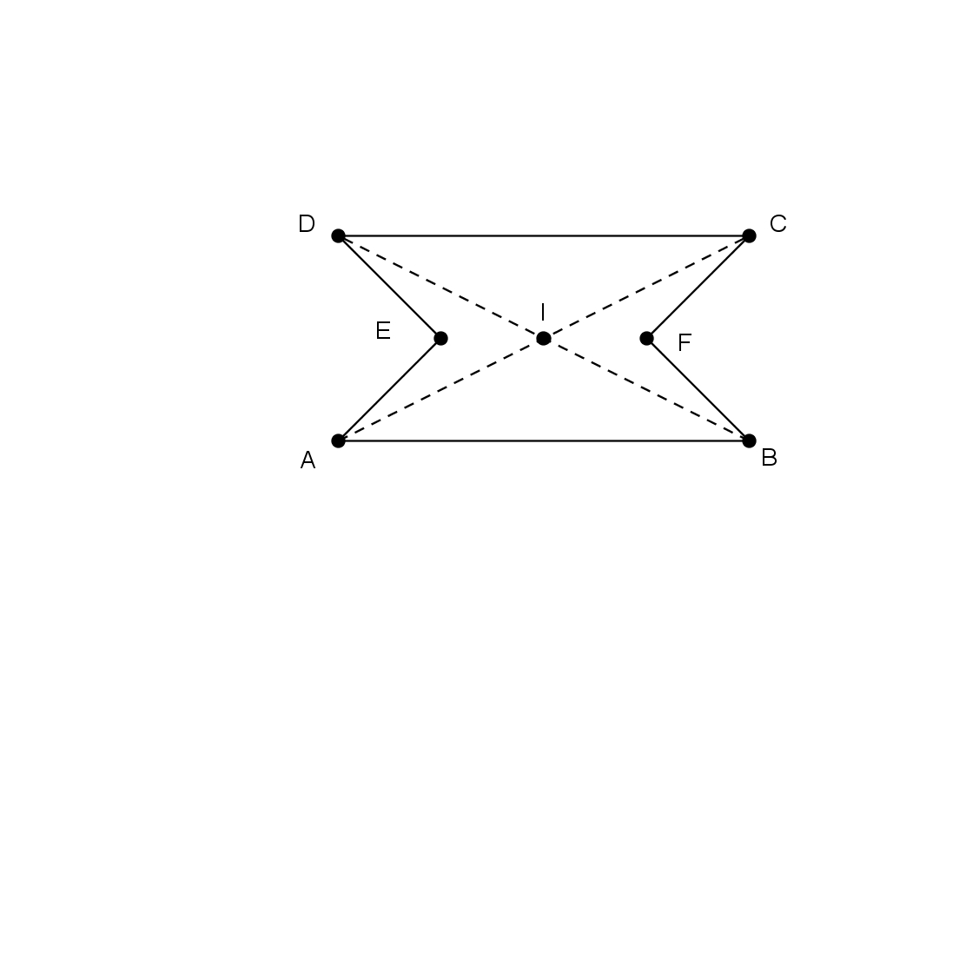
- The accompanying diagram in Figure 3 (a) shows the bottom view after all the folds have been created. Flip the paper over, so the front side is now facing up. Note, the valley folds will become mountain folds, and vice versa, the mountain folds have become valley folds, as desired. Next, push in the two valley folds, creating the isosceles triangle $B I A$ as in Figure 3 (b) below.

- (b)
Figure 3

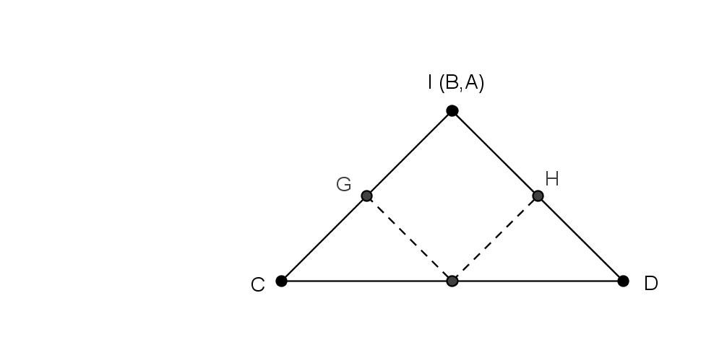
- From Figure 3 (b), fold vertex $B$ to vertex $I$, creating point $G$. Likewise, fold vertex $A$ to vertex $I$, creating point $H$, producing a regular square polygon on top of your isosceles triangle shown in Figure 4.

Figure 4
- Repeat the above steps with the remaining seven squares of paper. When you are finished you’ll have eight isosceles triangles.

- The rosette is made by hooking the isosceles triangles together. First it is helpful to stack all eight triangles up so that they are facing the same way. Take two triangles – a “first” one, labeled $C_{1}I_{1}D_{1}$, and a “second” one labeled $C_{2}I_{2}D_{2}$. Slide the second one into the first by placing both $I$ vertices together, and vertex $G_{2}$over $H_{1}$ as shown in Figure 5.

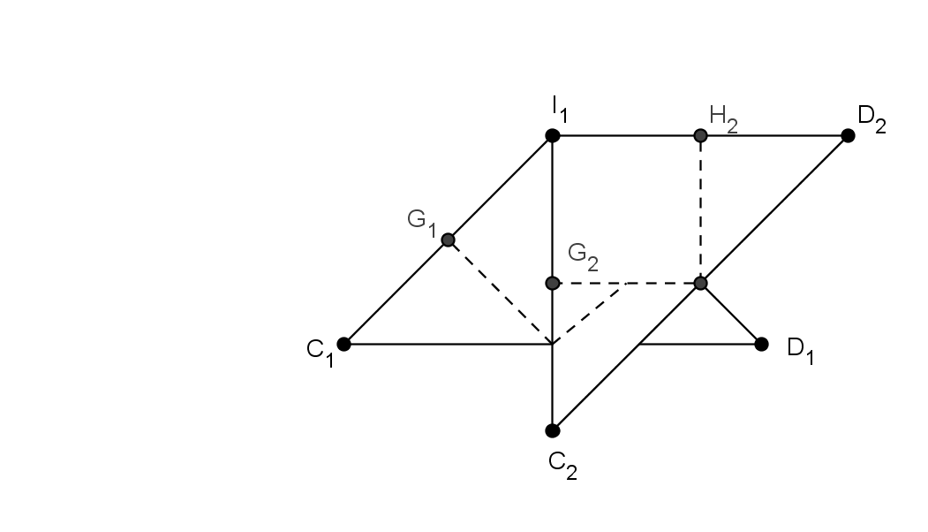

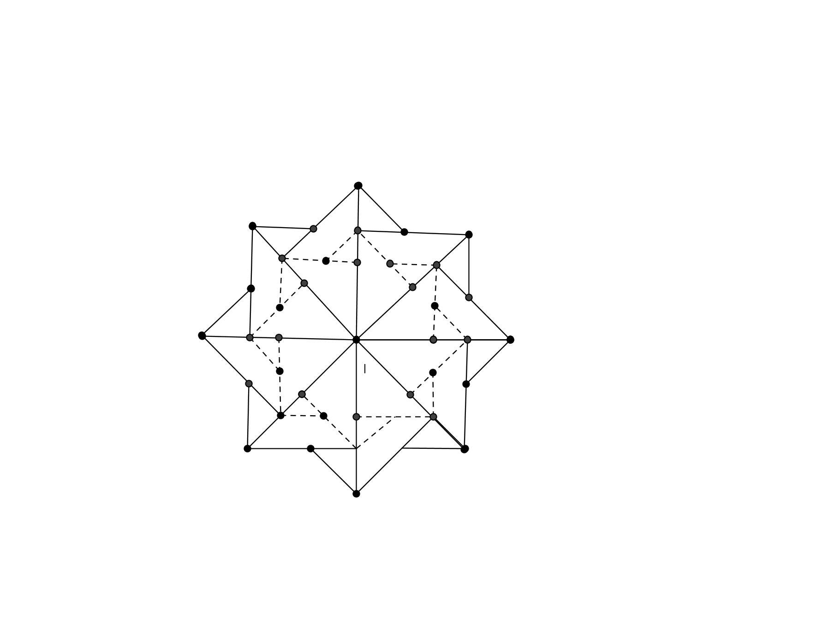
Figure 5

- Next, rotate the object $45°$ clockwise about $I.$ Repeat the previous step, until the rosette is complete. This is shown in Figure 6. When placing the final triangle follow the pattern already established to finish.

Figure 6

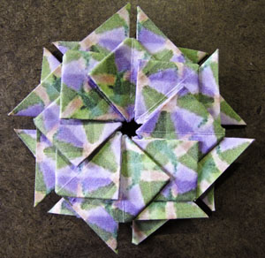

Figure 7

